Abstract 1
Introduction 2
Problem Description 3
COMPUTATIONAL THINKING AND PROBLEM ANALYSIS 4
FUNCTIONAL REQUIREMENTS 5
ALGORITHM DESIGN 6
PSEUDOCODE 7
FLOWCHART DESIGN 8
LOGICAL DESIGN 9
SUSTAINABLE DEVELOPMENT GOAL (SDG) INTEGRATION 10
OPEN SOURCE SOFTWARE JUSTIFICATION 11
DIGITAL PUBLIC GOODS (DPGs) JUSTIFICATION 11
GITHUB REPOSITORY AND VERSION CONTROL EVIDENCE 12
CONCLUSION 13
REFERENCES 14

Abstract
This report presents a logical design for a Student Attendance Tracking System intended for use in schools and communities in Sierra Leone. The proposed system addresses a practical education challenge: teachers and school administrators may record attendance but may not always have a simple method for turning attendance records into an attendance warning that a learner needs attention. The system therefore accepts basic attendance information, calculates an attendance percentage, classifies the learner into an attendance category, and produces an understandable output that can support timely follow-up.
Project terminology note: The project developed for this assignment is the Student Attendance Tracking System. The attendance-status feature (Good Attendance, At Risk and Critical) is included within the tracking system to help identify records that may require follow-up.
The assignment is designed as a programming-logic exercise rather than a completed software application. In line with the lecturer's instructions, no source code is required. Instead, the report demonstrates computational thinking, problem decomposition, an algorithm, pseudocode, flowchart design, decision structures, repetition, modular design and functions. It also explains how the proposed solution can be developed as an open-source project, how it could contribute to Sustainable Development Goal 4, and how it could potentially be developed toward the Digital Public Goods model.
The selected SDG is SDG 4: Quality Education, particularly Target 4.1, which focuses on ensuring that girls and boys complete free, equitable and quality primary and secondary education. The proposed system does not claim to solve school dropout by itself; rather, it provides a logical attendance monitoring and flagging mechanism that can help schools identify attendance patterns that deserve attention.

Introduction
Education is an important part of community and national development because it provides individuals with the knowledge, skills and abilities needed to participate effectively in society. In Sierra Leone, schools play an important role in developing young people and preparing them for future employment, further education and other responsibilities. However, for learners to benefit fully from teaching, classroom activities, practical work and other school programmes, regular participation and attendance are important.
Student absenteeism can negatively affect a learner’s academic progress. When a student frequently misses classes, the student may miss important lessons, assignments, assessments and explanations provided by teachers. If frequent absence is not identified early, it may become difficult for teachers and school administrators to provide the appropriate support. Therefore, schools need simple and effective ways of monitoring attendance and identifying students who may require attention.
In many schools, attendance information may be recorded manually in a register. Although this method allows teachers to record whether students are present or absent, the information may remain as individual marks without being converted into a clear indication of the student’s overall attendance level. This can make it difficult to quickly identify students whose attendance is becoming a concern, especially when a teacher has to monitor many students over a period of time.
A simple logical system can improve this process by taking attendance information as input, calculating the student’s attendance percentage and applying predefined decision rules. For example, the system can compare the calculated attendance percentage with a given threshold and determine whether the student has satisfactory attendance or requires attention. This provides a straightforward way of transforming raw attendance records into useful information that can support decision-making.

Problem Description
The problem is the difficulty of identifying students whose attendance has become low enough to require early attention. In a manual setting, a teacher may know that a learner has missed several days, but a school may not have a consistent method for calculating the learner's attendance percentage and classifying the level of concern.
Who Is Affected?
Students who may miss learning opportunities when attendance becomes irregular.
Teachers who need a simple way to review attendance information.
Parents or guardians who may need to be informed when attendance becomes a concern.
School administrators who need summarized attendance information for follow-up and planning.
Why the Problem Exists
Attendance may be recorded manually and reviewed only when a problem becomes obvious.
Different teachers may use different ways of judging whether attendance is a concern.
Large numbers of learners can make manual checking time-consuming.
Attendance records may show numbers but not automatically provide a clear category or warning.
Proposed Solution
The proposed Student Attendance Tracking System is a simple logical model. For each learner, the system receives the learner's identification information, the number of school days scheduled, and the number of days attended. It calculates attendance using the formula: Attendance Percentage = (Days Attended ÷ Total School Days) × 100. The result is then compared with the project's decision thresholds.
For this assignment, the logical classification is: 90% or above = Good Attendance; 75% to below 90% = At Risk; below 75% = Critical. These thresholds are design rules for the proposed assignment model and should be reviewed with school authorities before real-world deployment.
Community Impact Rationale
The proposed system is intended to support earlier identification rather than punish students. A teacher can use the output to decide whether a learner needs a conversation, parent/guardian contact, academic support, or another appropriate intervention. The system therefore turns a basic attendance record into information that is easier to understand and act upon.
The project is also suitable for Sierra Leone because the core logic is simple and can be adapted to different school sizes. A first version could work with basic attendance records without requiring complex artificial intelligence or expensive infrastructure. The same logical design could later be implemented in a mobile, web or desktop system, depending on the resources available to a school.

COMPUTATIONAL THINKING AND PROBLEM ANALYSIS
Decomposition
The large problem is divided into smaller tasks so that each task can be designed and tested independently:
Collect learner information and attendance data.
Validate the basic inputs so that impossible values are not accepted.
Calculate the attendance percentage.
Compare the percentage with the defined thresholds.
Assign an attendance status.
Display the result clearly.
Repeat the process for other learners when required.
Produce a summary that can help a teacher identify learners requiring attention.
Pattern Recognition
The system looks for a repeated pattern: low attendance percentages indicate a greater need for follow-up. Instead of treating every attendance record as a separate decision, the same classification rules are applied consistently to each learner.
Abstraction
The system does not need every detail of a learner's personal life to perform the attendance calculation. For the core logic, the important information is the learner identifier, total school days and days attended. Other information can remain outside the calculation unless it is needed for a later school process.
Algorithmic Thinking
The solution follows a defined sequence of actions. The same sequence can be repeated for multiple learners, while decision statements determine which attendance category is produced. This makes the process predictable, testable and suitable for implementation in a programming language later.
Computational Thinking Summary
Concept | Application in the proposed system
Decomposition | Break attendance monitoring into input, validation, calculation, classification and output.
Pattern Recognition | Apply the same attendance rules to each learner.
Abstraction | Use only the information required for the attendance calculation and warning.
Algorithmic Thinking | Follow an ordered procedure that can be implemented and tested.

FUNCTIONAL REQUIREMENTS
System Inputs
Student ID or student name.
Total number of school days for the period.
Number of days attended.
Optional class/grade information for identification and reporting.
Processing
Check that total school days are greater than zero.
Check that days attended are not negative.
Check that days attended do not exceed total school days.
Calculate the attendance percentage.
Compare the percentage against the decision thresholds.
Assign the appropriate attendance status.
Outputs
Attendance percentage.
Attendance category: Good Attendance, At Risk, or Critical.
A simple recommendation for follow-up when the learner is At Risk or Critical.
Non-Functional Considerations
The design should be simple enough for school staff with basic digital skills.
The system should be understandable and easy to maintain.
Student information should be handled responsibly and only for legitimate educational purposes.
The design should allow future expansion without changing the basic attendance logic.

ALGORITHM DESIGN
Step-by-Step Algorithm
Start.
Enter the student's ID/name.
Enter the total number of school days.
Enter the number of days attended.
Check whether the total school days are greater than zero.
If not, display an invalid-input message and request the data again.
Check whether days attended are between zero and total school days.
If not, display an invalid-input message and request the data again.
Calculate attendance percentage = (days attended / total school days) × 100.
If attendance percentage is 90% or above, set status to Good Attendance.
Otherwise, if attendance percentage is 75% or above, set status to At Risk.
Otherwise, set status to Critical.
Display the student information, attendance percentage and status.
Ask whether another learner should be processed.
If yes, repeat the process; otherwise, end

PSEUDOCODE
The following pseudocode represents the logical solution without using a specific programming language:
BEGIN
Function Main
Declare Integer numStudents, daysPresent, totalDays, i
Declare Real rate
Declare String studentName, status
Declare Integer goodCount, riskCount, criticalCount

Output "Enter number of students"
Input numStudents
Output "Enter total school days"
Input totalDays
Assign goodCount = 0
Assign riskCount = 0
Assign criticalCount = 0
For i = 1 to numStudents
Output "Enter student name"
Input studentName
Output "Enter days present"
Input daysPresent
Assign rate = daysPresent * 100 / totalDays
If rate >= 90
Assign status = "Good"
Assign goodCount = goodCount + 1
Else
If rate >=75
Assign status = "At Risk"
Assign riskCount = riskCount + 1
Else
Assign status = "Critical"
Assign criticalCount = criticalCount + 1
End
End
Output studentName & " " & rate & "% " & status
End
Output "Good: " & goodCount
Output "At risk: " & riskCount
Output "Critical: " & criticalCount
End END WHILE
END
The pseudocode demonstrates sequence, selection and repetition. The WHILE structures provide repetition, while the IF/ELSE IF/ELSE structure provides decision-making.

FLOWCHART DESIGN
The flowchart should show the complete logic from Start through input validation, attendance calculation, classification, output and the decision to process another learner. The actual flowchart can be produced in Flowgorithm, draw.io or Mermaid, as permitted by the assignment brief.
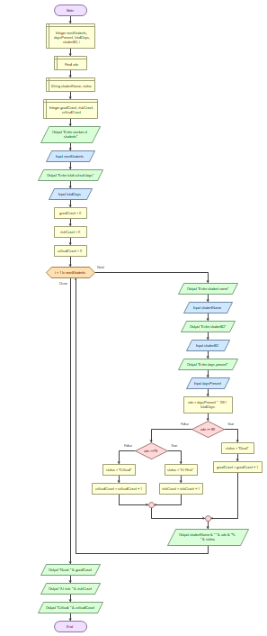

LOGICAL DESIGN
Input
The system receives the student identifier, total school days and days attended. These values are sufficient for the main attendance calculation.
Processing
The main processing operation is the attendance percentage calculation. After calculating the percentage, the system applies the classification rules.
Decision Structures
A nested decision structure is used. The first decision checks whether the attendance percentage is at least 90%. If that condition is false, the second decision checks whether the percentage is at least 75%. If both are false, the result is Critical.
Repetition Structures
A WHILE loop is used to process multiple learners. Another validation loop can be used to keep requesting attendance data until the values are valid.
Modular Design
The system can be divided into modules so that each part has one clear responsibility:
Module/Function | Main responsibility | Expected result
getStudentData() | Collect student identification and attendance inputs. | Valid input values.
validateAttendance() | Check whether attendance values are logical. | Valid/invalid result.
calculateAttendance() | Calculate the attendance percentage. | Attendance percentage.
classifyAttendance() | Apply the attendance thresholds. | Status category.
displayResult() | Present the result to the user. | Readable attendance report.

SUSTAINABLE DEVELOPMENT GOAL (SDG) INTEGRATION
Selected SDG: SDG 4 – Quality Education
The project supports SDG 4: Quality Education. The most direct connection is Target 4.1, which calls for all girls and boys to complete free, equitable and quality primary and secondary education leading to relevant learning outcomes (United Nations, 2026).
Relationship Between the System and SDG 4
The system focuses on a school participation issue that can affect a learner's ability to benefit from education.
It helps schools identify attendance concerns earlier so that appropriate support can be considered.
It supports more consistent use of attendance information.
It can contribute to better monitoring and school-level decision-making when used responsibly.
Limits of the SDG Contribution
The system is not a complete solution to education inequality, absenteeism or dropout. Attendance can be affected by many factors, including health, household responsibilities, transport, finances and school conditions. The proposed system only provides an attendance monitoring and flagging mechanism. Human follow-up and wider educational support remain necessary.

OPEN SOURCE SOFTWARE JUSTIFICATION
Why the Proposed Solution Should Be Open Source
Making the project open source would allow other students, teachers, developers and education organisations to inspect the logical design, adapt it to local needs and contribute improvements. GitHub describes a repository as a place where project files and their revision history can be stored and managed, making it suitable for documenting the evolution of the project (GitHub, 2026).
Benefits for Sierra Leone
Schools and local developers could adapt the design to different school structures.
Students could learn programming logic from a real local problem.
Future developers could improve the system without starting from zero.
The project could be reviewed and improved through community contributions.
An open design can reduce dependence on one developer or one institution.
Potential Community Contributions
Improved attendance-reporting modules.
Translations and clearer user interfaces for local contexts.
Better documentation and testing.
Additional school-level reports, subject to privacy and safeguarding requirements.
Technical improvements that allow operation in low-connectivity environments.

DIGITAL PUBLIC GOODS (DPGs) JUSTIFICATION
What Is a Digital Public Good?
The Digital Public Goods Alliance defines digital public goods as open-source software, open data, open AI systems and open content collections that comply with relevant privacy and safety requirements, do no harm by design and help attain the Sustainable Development Goals (Digital Public Goods Alliance, 2026).
How the Proposed System Could Become a DPG
The proposed attendance system is not automatically a Digital Public Good simply because it is open source. It would need to be developed and reviewed against the relevant DPG Standard. The DPG Standard includes requirements such as SDG relevance, open licensing, clear ownership, platform independence, documentation, responsible data practices, privacy and security (Digital Public Goods Alliance, 2026).
DPG consideration | How this project addresses it | Evidence to add later
SDG relevance | The project is designed around SDG 4 and quality education. | SDG section in README/report.
Open licence | A suitable open-source licence can be selected for the repository. | Licence file/screenshot.
Documentation | The repository can include a README explaining the logic and setup. | README screenshot.
Platform independence | The core logic is expressed through algorithms and pseudocode rather than being tied to one vendor. | Design documentation.
Privacy and safety | Only necessary attendance information should be processed, with responsible handling of student data. | Privacy/design notes.

GITHUB REPOSITORY AND VERSION CONTROL EVIDENCE
The screenshot below provides evidence of my GitHub repository for the Student Attendance Tracking System. The repository contains the files and project work developed for this assignment, including the algorithm, pseudocode, flowchart and related documentation. This demonstrates that the project work has been organised and uploaded to GitHub as required.
GITHUB URL LINK: https://github.com/bahsulaimanyerroh01-gif/PROG101_Assignment1_Sulaiman-Yerroh-Bah_905005976
Repository Evidence Placeholders
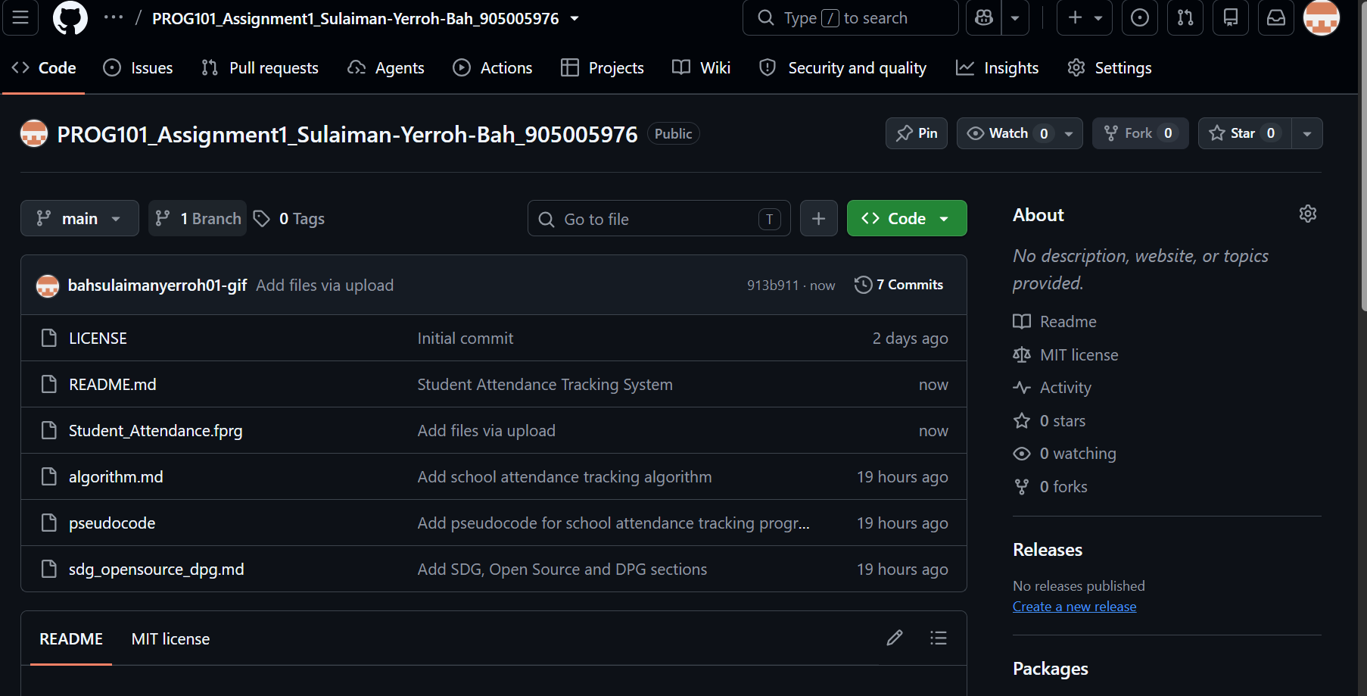
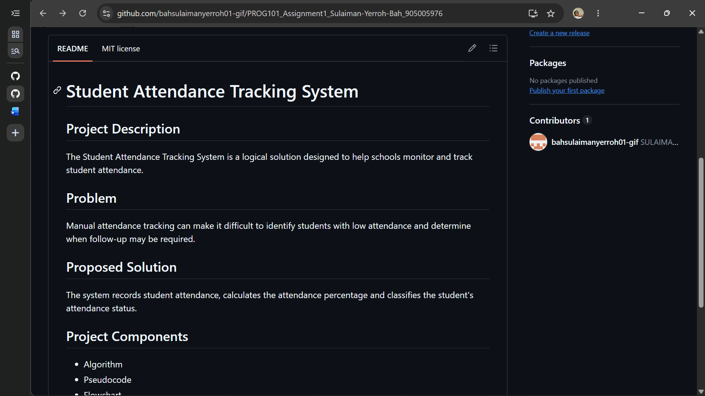

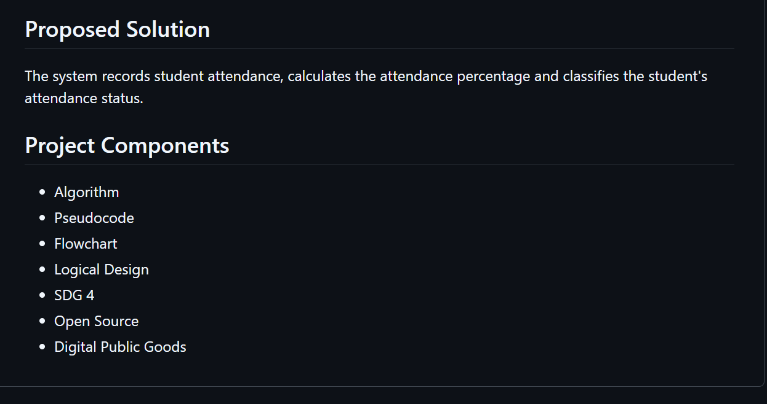

CONCLUSION
This report has presented a complete logical design for a Student Attendance Tracking System addressing a practical education-related challenge in Sierra Leone. The proposed solution uses a simple input-process-output structure, decision rules and repetition to transform attendance records into understandable attendance categories.
The design demonstrates the programming-logic requirements of the assignment through computational thinking, decomposition, pattern recognition, abstraction, algorithm design, pseudocode, flowchart planning, decision structures, repetition, functions and modular design. The system is intentionally presented as a logical solution rather than a completed software application because the assignment states that students are not required to write source code.
The project also connects the technical design to SDG 4, particularly Target 4.1, and explains how an open-source approach could support wider adaptation and learning. With careful privacy practices, proper documentation and compliance with the Digital Public Goods Standard, the project could potentially be developed further as a public-interest digital solution. The final practical value will depend on responsible implementation, school participation and appropriate human follow-up when attendance concerns are identified.

REFERENCES
Digital Public Goods Alliance (2026) Digital Public Goods Standard. Available at: https://www.digitalpublicgoods.net/standard (Accessed: 8 October 2026).
Digital Public Goods Alliance (2026) DPG Application FAQs. Available at: https://www.digitalpublicgoods.net/digital-public-goods/faqs (Accessed: 8 October 2026).
GitHub (2026) About repositories. GitHub Docs. Available at: https://docs.github.com/en/repositories/creating-and-managing-repositories/about-repositories (Accessed: 8 October 2026).
GitHub (2026) About Git. GitHub Docs. Available at: https://docs.github.com/en/get-started/using-git/about-git (Accessed: 8 October 2026).
United Nations Department of Economic and Social Affairs (2026) Goal 4: Quality Education. Available at: https://sdgs.un.org/goals/goal4 (Accessed: 8 October 2026).

